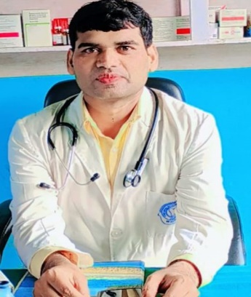
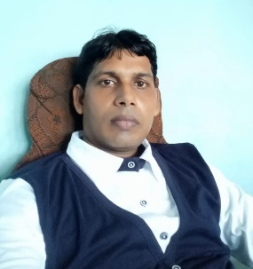
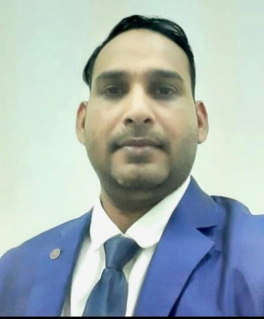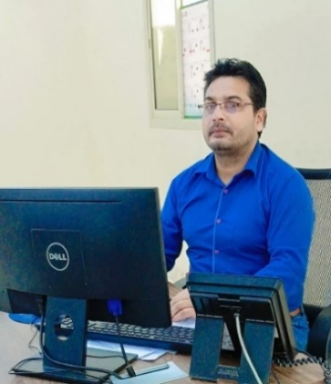
DIRECTOR DIRECTOR HOD SCIENCE & MEDICAL HOD IT & COMPUTER
ER. MR. SIR AK. SIR DR. MJ. SIR IT. SIR
ER. MUKHTAR ANSARI MR. ASHFAK ANSARI DR. MUMTAJ ANSARI MR. IMTEYAT ANSARI
(HOD MATHS & EDUCATION) (HOD ENGLISH & GLOBAL PLACEMENT) (BDS,BLS,Medanta Gurugram/ (PGDCA & Computer Software Professional
(B.Tech, EE, MMMUT Gorakhpur, (M.A. English American Literature PIDS, GKP) From Govt. Polytechnic,Deoria.)
UPSEE-Rank -59 in 2012. B.ed.,DDU Global Manager,Chicago,USA
University,GKP,President of SSS,NGO ) PG in Marketing & Sales Management)

Message
“I experienced during my practical life these four keywords (CKPP) which always stands out your skill outstanding. Follow these and you will be adorned with great success.”
C-Confidence K-Knowledge P- Patience P-Positivity -AK. SIR

“A good education is the foundation of a better future.”

-MR. SIR

About
Greetings to all my dear readers and viewers!
We provide basic and competitional knowledge to the students. We have been a remarkable history in the field of education and career build up. We specialize to shape the future of the students on their hidden talents basis. No student should be categorize as fast or poor on the basis of their score card.
We search out the potential of the students and shape their career with desired training and coaching to develop their personality. Our core values have been given below :-
* We provide both online and offline abode for the students classes/admission/attendance etc.
* We provide Distance Learning Programme(DLP) for the remote students or as per their accessibility.
* We provide whole education solution like - *Boards (UP/CBSE/ICSE) *Preparation * University Courses * Vocational Courses *Training & Placement ( Both National & Global)
*We provide time to time motivational speech and debate for the personality development.
* Thousands of our alumni were adorned with degrees/certificates and lightening the world with their success story.

WE ARE READY TO SHAPE YOUR FUTURE NICELY
Join KNOWLEDGE KING EDU PVT LTD for career/degrees/certificates/knowledge/training/job placement and entire education solution relevant to your skill and calibre. We shape your career at all.

Thank you to all.

Profile (AK. SIR)
Greetings to all my readers and viewers. I belong to a medium family and was born in a village Sauna Lachhuman in the district of Deoria primarily known as Deoghar in the state of Uttar Pradesh, India.
I got my primary education from my village primary school Sauna Lachhuman and had immense interest in speaking and learning English since my those days. My father was also B.Sc. Mathematics and always used to focus and tell the importance of knowledge. He used to provide all the supplies especially studies’ materials. I have been remarkable student in English from primary till Master of English. Never counted the marks in my result, I have been an excellent learner and speaker of English with grammatical orders. Till my Junior School 8th standard, I had finished all the terms of English Grammar.
During graduation from DDU University, Gorakhpur , I used to hold tuition from 9th to 12th and even the graduate students. I used to teach the students of all the boards CBSE/ICSE and UP as tuition under the name of MM Tutorials which was run by our brothers MJ Sir, MR Sir and me.
Later, I resolved to open a CBSE school and ultimately it was established in 2012 under the name of KNOWLEDGE KING ACADEMY. We all four brothers have been expert in different subjects as we confess this gift, the mercy and grace of God. One of my brothers MJ Sir has been expert in Chemistry, Biology and Physics too. The second one MR Sir has been expert in Mathematics and Physics. My elder brother IT Sir has been expert in Computer and IT. Me myself have been expert in English and Social Studies. So we have a complete competitional faculty for all the subjects. Since 2012 to 2018, only one institute was famous in the town of Hata, Kushinagar. We run super thirty batch and educate them well and minute mechanism of teaching methods. All my students were secured 100% CGPA for nearly all the super thirty batch.
Further, I was selected as Area Business Manager Burger King Company , Miami , Florida, USA under the franchise of KSA ( Kingdom of Saudi Arabia). I used to manage there citizens of multi nationalties which was really an enthusiastic for me to be represent as global manager with only the power of fluent English and logic which is my god gifted virtue. Always I have seen the impossible dream. Really I feel excitement to gain unachievable goal. Either you fail or learn, Never defeat. Defeat is your death only. Nobody can perform greatness after his/her death so live freely and think freely during this mortal life.
Presently , It was observed that new abode of education has been replaced for the old method of physical chalk-board teaching method. Now-a-days degree is easier than to getting knowledge. So this is my message to all my dear readers to be smarter than hard worker. Smarter in the sense of swiftly observing the facts and storing into the mind with accuracy.
Join KNOWLEDGE KING EDU PVT LTD for career/degrees/certificates/knowledge/training/job placement and entire education solution relevant to your skill and calibre. We shape your career at all.

Thank you to all.

Profile ( MR. SIR)
Greetings to all my readers and viewers.
Since my primary education I have been interested in Mathematics and Physics. I got my primary , secondary and senior secondary education in Hind medium from my state board. I have more than 10 years experience in teaching CBSE/UP/ICSE boards students.
Boards syllabus and competitional preparation both run together for the complete growth of students. Such students all the time do best performance. I make my students practical and logical. To provide them the basic and fundamental knowledge is our motive because without foundation we cannot build a sky-height tower. As well as the same without fundamental knowledge we cannot crack any competition.
So I always focus to my students to be practical than theoretical. Practical knowledge is the best form of education. Read and understand the fact thoroughly. Books are the bricks of success- building.

“A good education is the foundation of a better future.”

-MR. SIR

Profile ( MJ. SIR)
Greetings to all my readers and viewers.
Since my primary education I have been interested in Science. I got my primary , secondary and senior secondary education in Hind medium from my state board. I have more than 15 years experience in teaching CBSE/UP/ICSE boards students. Specially Chemistry and Biology.
Boards syllabus and competitional preparation both run together for the complete growth of students. Such students all the time do best performance. I make my students practical and logical. To provide them the basic and fundamental knowledge is our motive because without foundation we cannot build a sky-height tower. As well as the same without fundamental knowledge we cannot crack any competition.
So I always focus to my students to be practical than theoretical. Practical knowledge is the best form of education. Read and understand the fact thoroughly. Books are the bricks of success- building.

“There is no short- cut way to get complete knowledge.”

-MJ. SIR

Profile ( IT. SIR)
Greetings to all my readers and viewers.
Since my primary education I have been interested in Computer and IT . I got my primary , secondary and senior secondary education in Hind medium from my state board. I have more than 10 years of experience in teaching computer.
As we know that this is the era of computer. I had already this idea before 20 years and I was interested to have knowledge in the field of computer software and hardware. I remembered those days when huge crowd of students used to come to my compute education center to learn the basic knowledge of computing.
As the time changes more advanced form of computer and IT is being used and all the times we keep update with the new form of IT and keep run with advanced modern technology and speed.

“Be smarter than hard worker.”

-IT. SIR

